Machine | Picture | Model
Punch Press | 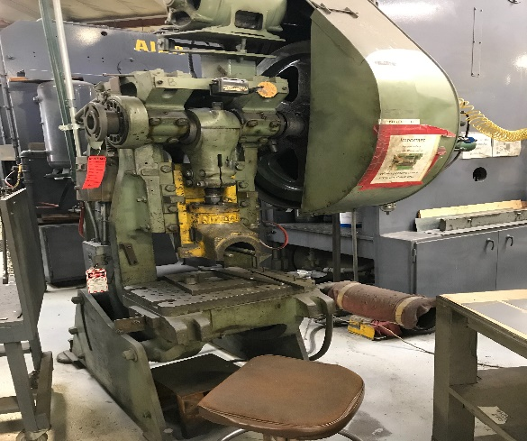 | - NIAGRA 27629 A-3  - Slight mechanical issue.  - runs
Time Saver | 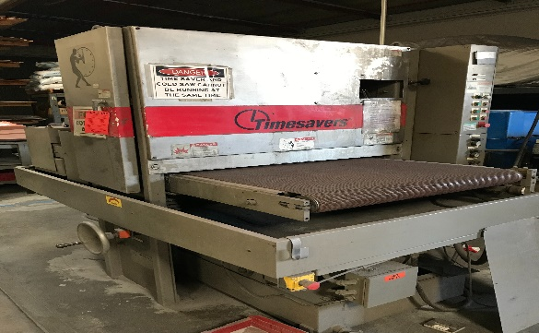 | - model: P831330-01-0016 TIMESAVER  - 24” WIDTH  - 100 YARD LENGTH  - 80 MICRON  - currently not running
Band saw | 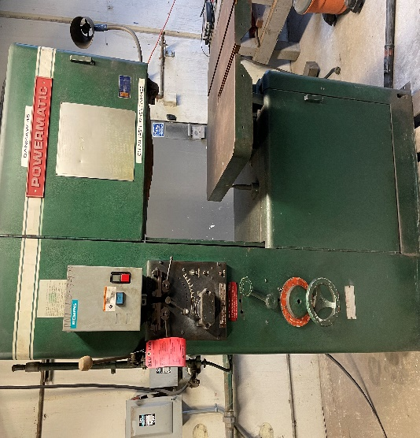 | - PowerMatic band saw  - CUrrently not running  - Very easy mechanical fix
Conv Mill | 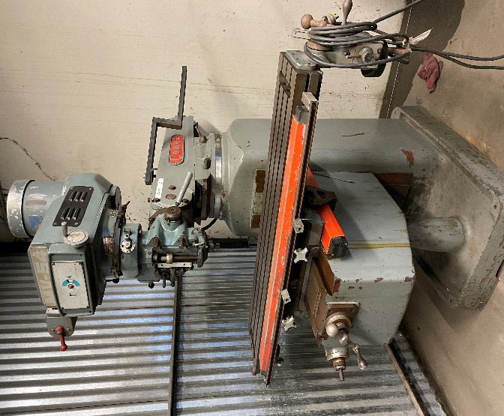 | - MV-54 COMET CONVENTIONAL MILL  - Unsure if power feeder works  - Unplugged 6 years ago, worked perfectely before stop using
Jigbo | 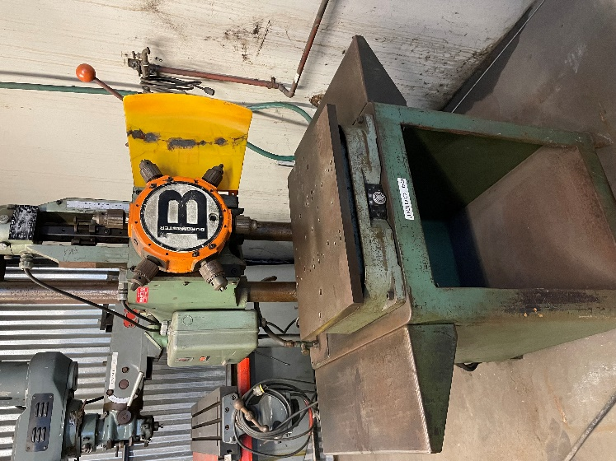 | - BURGMASTER HOUDAILLE 5797
Saw | 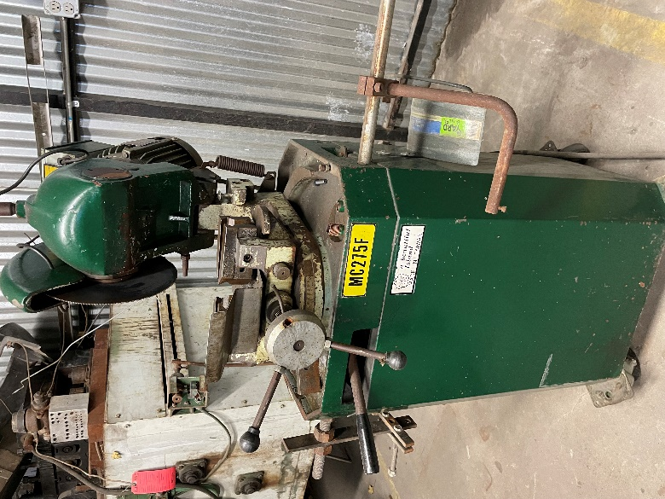 | - MC275F SAW 99’  - 3 PHASE MOTOR
Coil Handler | 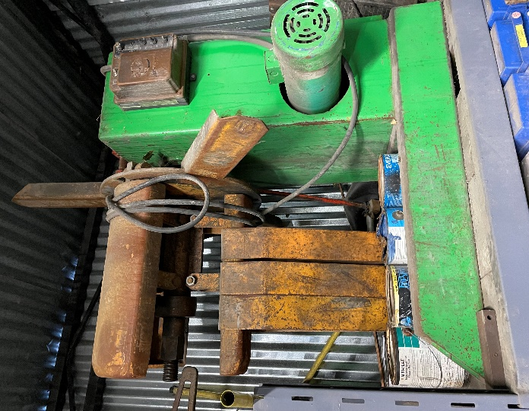 | Never found use for it
EDM | 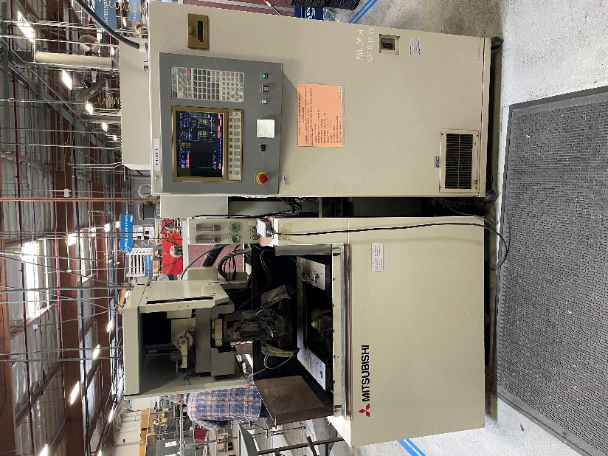 | - MITSUBISHI FX1  - BOUGHT IN 96’ ORIGINAL OWNER  - Runs great  - Good condition

